**StatsLibrary Documentation**

**By Chris Ricchi**

**Introduction**

Welcome to the Stats Library program, a program to help calculate the answers to the topics that we’ve gone over during class. This program can take specific input and solve questions for the following topics:

* Mean, Median, Mode
* Standard Deviation and Variance
* Factorial, Permutations and Combinations
* Correlation and Dependency
* Union, Intersection, and Compliment
* Conditional Probability and Baye’s Theorem
* Binomial Distribution and multiple Geometric Distributions
* Hypergeometric Distribution
* Negative Binomial Distribution
* Poisson Distribution and Chebyshev’s Theorem

**Using StatsLibrary Program**

This program functions with the use of three classes: **StatsLibrary, TestStatsLibrary,** and **StatsLibraryGUI.**. The first class, **StatsLibrary**, contains each individual method to calculate for each topic. There is a single method for each of the topics listed above. For problems that require comparing of lists, the methods require ArrayLists as inputs. For other problems that return numeric values, we represent all numbers as doubles with significant figures for accurate results. The second class, **TestStatsLibrary**, is used as a console-based text tester for the first class. This class tests each method in detail using the console. All output is printed to the console in a formatted manner. Lastly, the **StatsLibraryGUI** class combines both previous classes and presents the user with a GUI where they can manually click a button for each function. Then, the user will be asked for input that makes sense in the context of the function. For example, the Find Mean button is going to prompt the user to enter numbers in a comma-separated format (which creates an ArrayList). More complicated methods, such as hypergeometric distribution, allow the user to enter a y, N, n, and r in accordance to the hypergeometric formula.

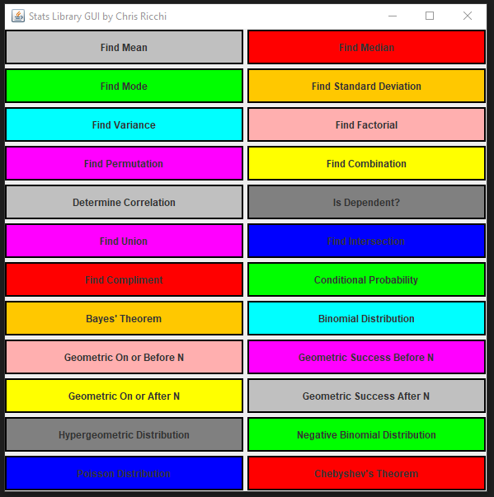

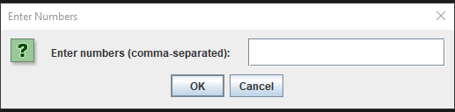

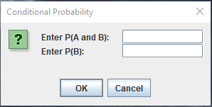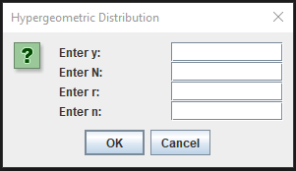

**Understanding the Results**

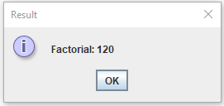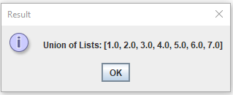The results of each function are in direct relation to the given formulas or expressions. For all 24 functions, there is unique input and output depending on what the user enters into the program. All results for each function will be printed to the window of the GUI in a similar fashion to how input is accepted.

Ultimately, the output is dependent on the chosen values. The **TestStatsLibrary** class contains accurate test classes derived from in-class work and homework problems.